Screen capture of the deployment of docker

Screen capture of the services’ status

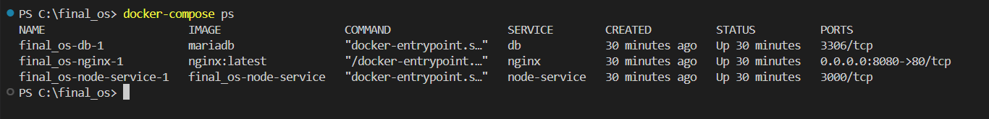

Screen capture of accessing application

screen capture of before scale up

screen capture of after scale up

